W1:

1. <https://keycloud.zeekay.dev/2019/10/06/week-01-keycloud/>

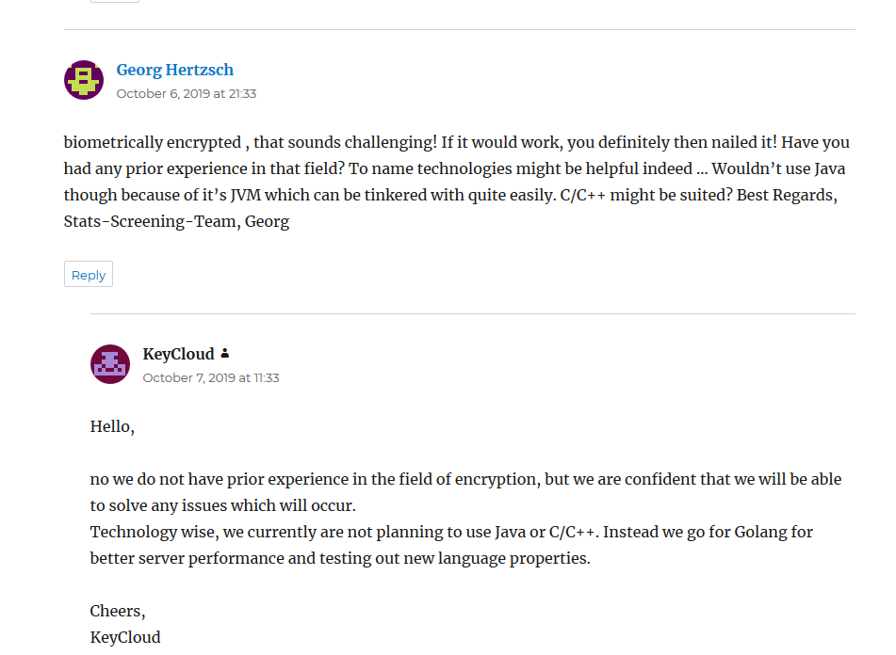

1. <https://evendo.gnaatz.de/?p=22>

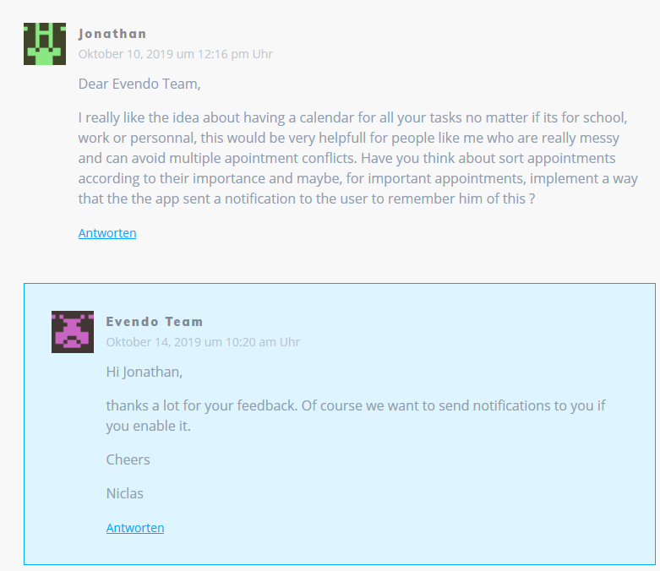

1. <https://dh-towerdefense.de/week-1-project-vision/>

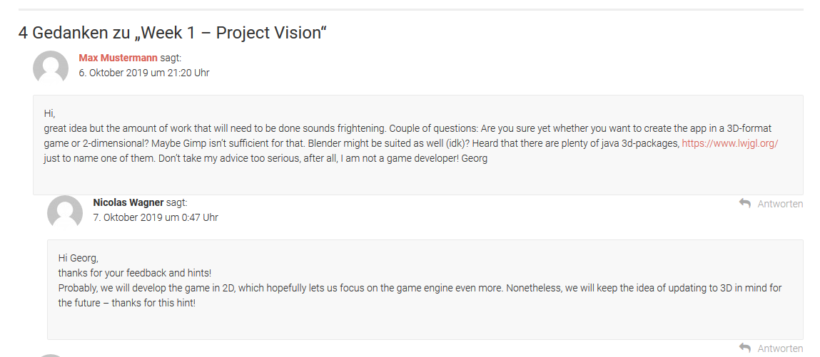

W2: We were not able to find our Peer Review-Comments again (they were deleted). We added new ones again.

1. <https://pipossible.wordpress.com/2019/10/13/our-team-roles/comment-page-1/#comment-19>

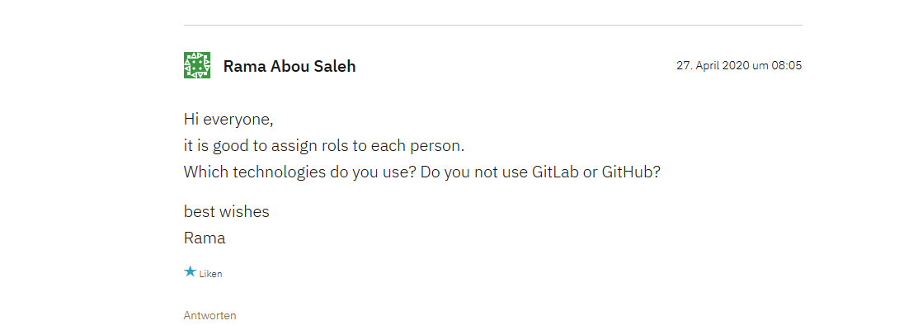

We were not able to find our Peer Review-Comments again (they were deleted). We added new ones again.

1. <https://softwareengineeringtinf18b3.wordpress.com/2019/10/09/week-2-organisation/comment-page-1/#comment-31>

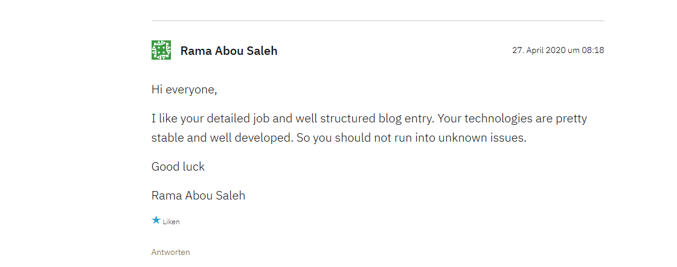

W3:

1. <https://dh-towerdefense.de/week-3-srs-and-ucd/>

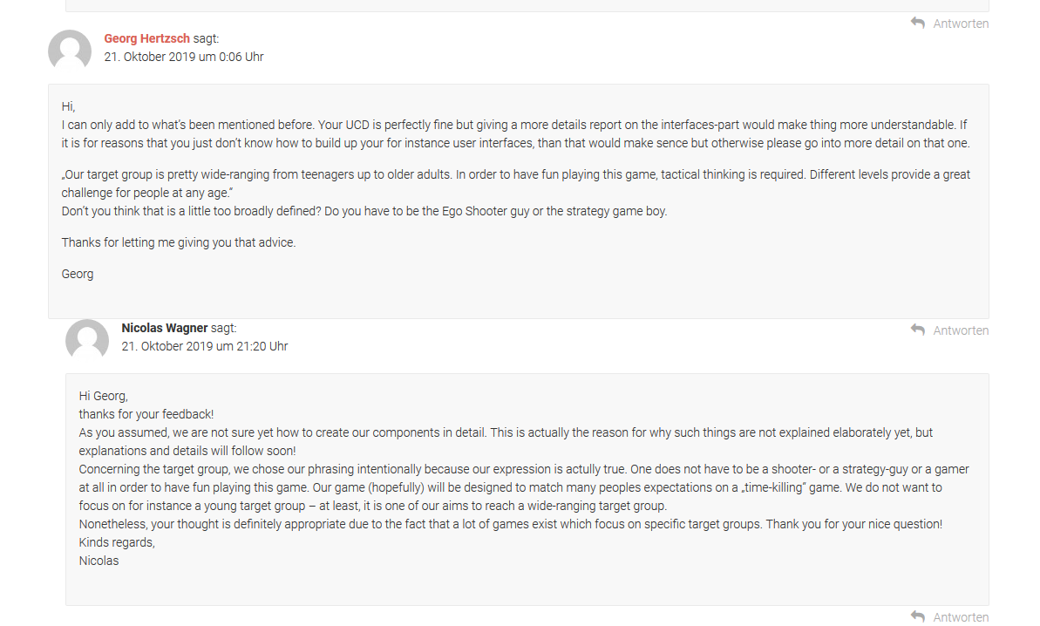

We were not able to find our Peer Review-Comments again (they were deleted). We added new ones again.

1. <https://softwareengineeringtinf18b3.wordpress.com/2019/10/23/w3-srs-and-uml/comment-page-1/#comment-32>

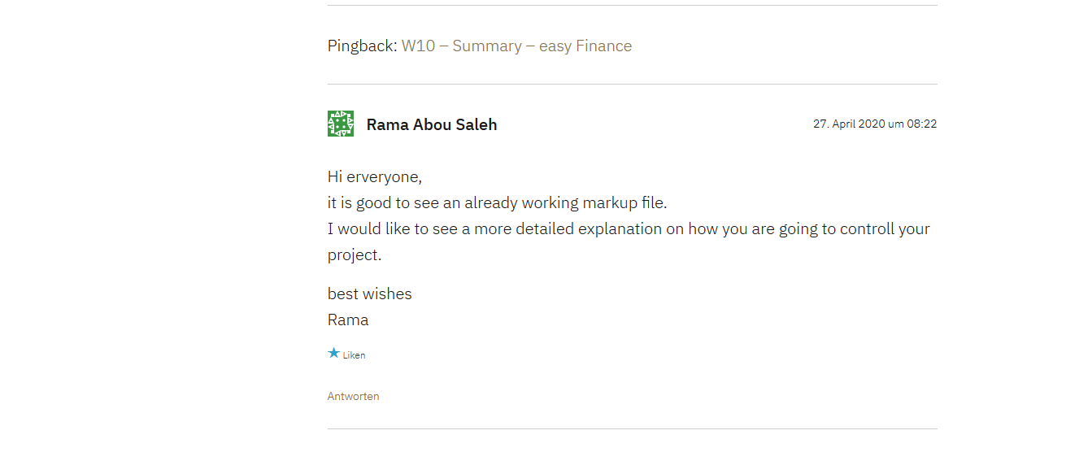

W4:

1. <https://cardgames979849195.wordpress.com/2019/10/27/week-4-use-cases/>

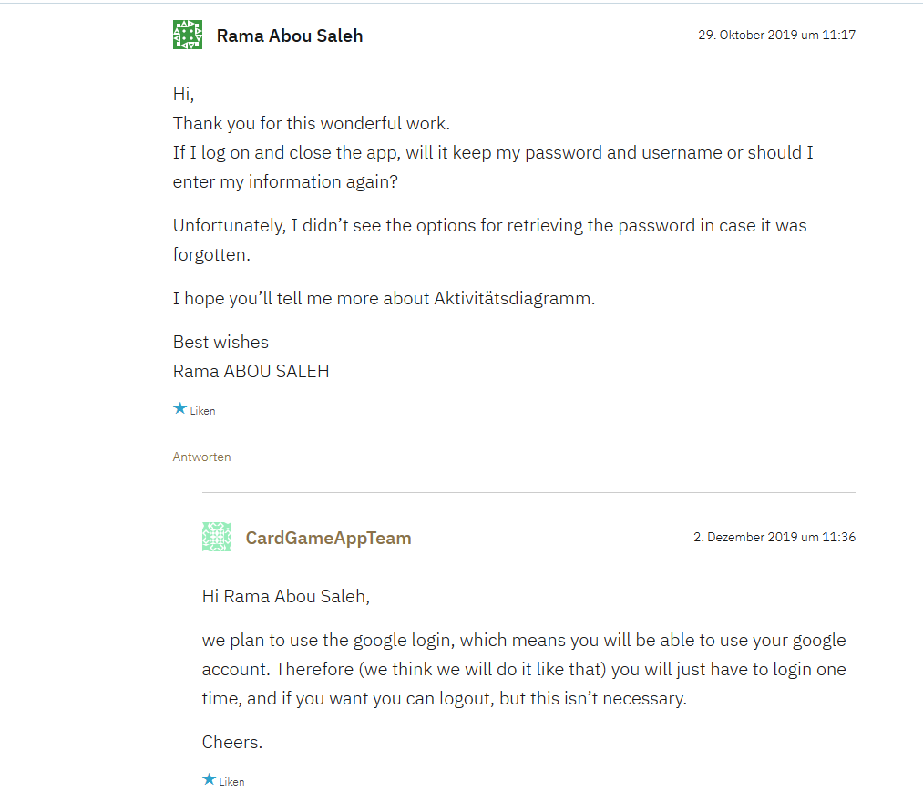

1. <https://blog.hoppercloud.net/2019/10/25/first-use-cases/>

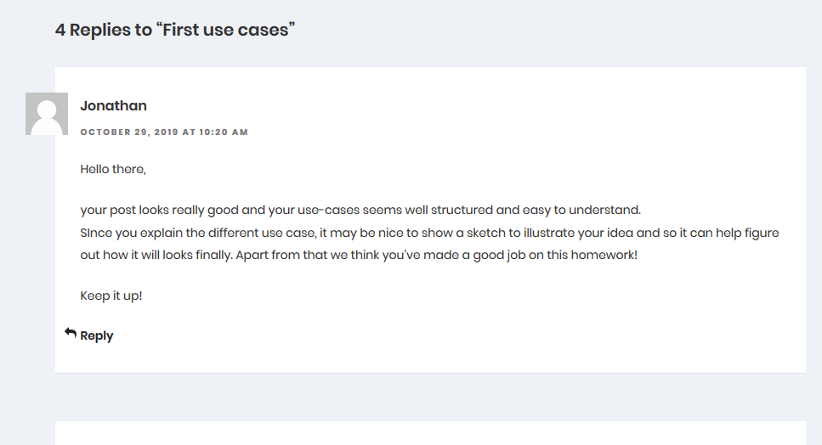

W5:

1. <https://itemizeproject.wordpress.com/2019/10/28/week-5-tests-with-cucumber/>

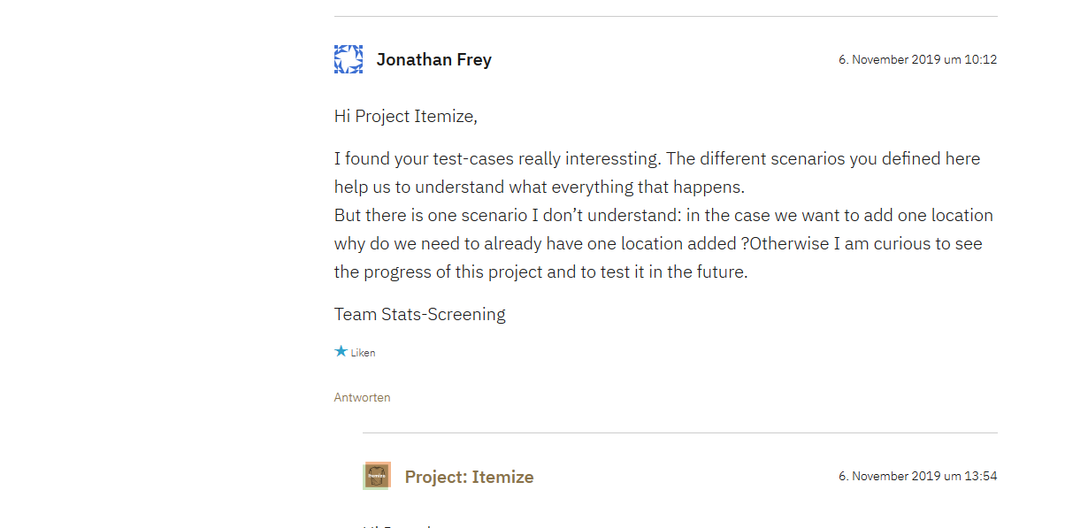

We were not able to find our Peer Review-Comments again (they were deleted). We added new ones again.

1. <https://pipossible.wordpress.com/2019/11/06/blog-w5/comment-page-1/#comment-20>

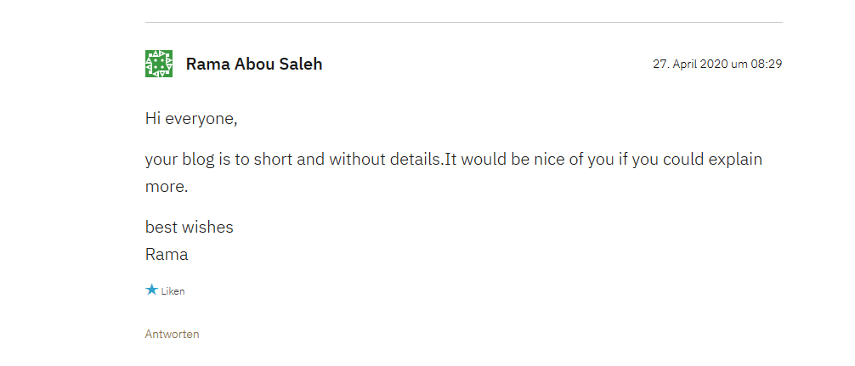

W6:

We were not able to find our Peer Review-Comments again (they were deleted). We added new ones again.

1. <https://evendo.gnaatz.de/?p=53#comment-38>

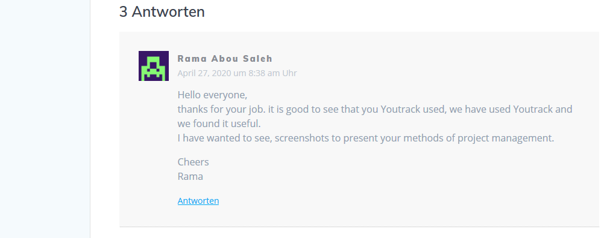

We were not able to find our Peer Review-Comments again (they were deleted). We added new ones again.

1. <https://gyrogame.de/2019/11/14/week-6-project-management-scrum-board/#comment-60>

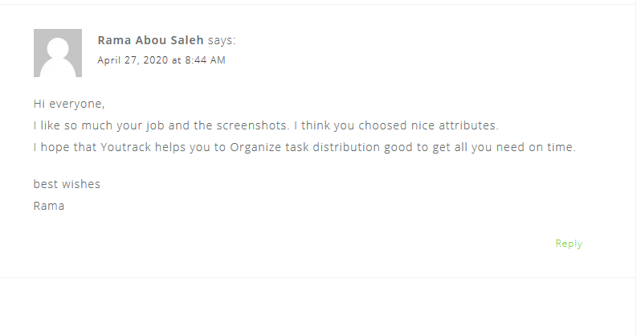

W7: 1. <https://evendo.gnaatz.de/?p=58#comment-29>

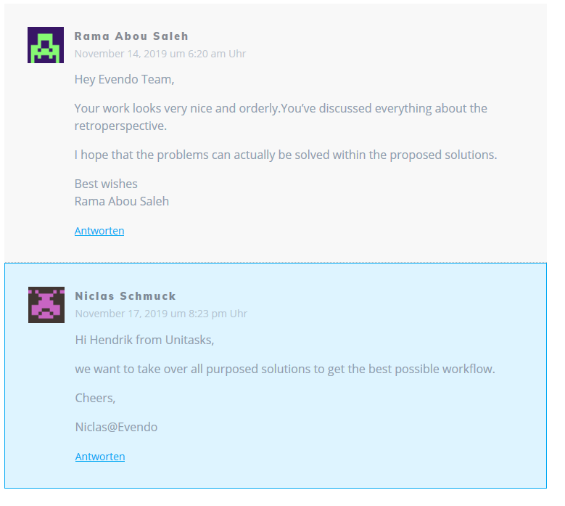

2.<https://keycloud.zeekay.dev/2019/11/11/week-07-retrospective/#comment-30>

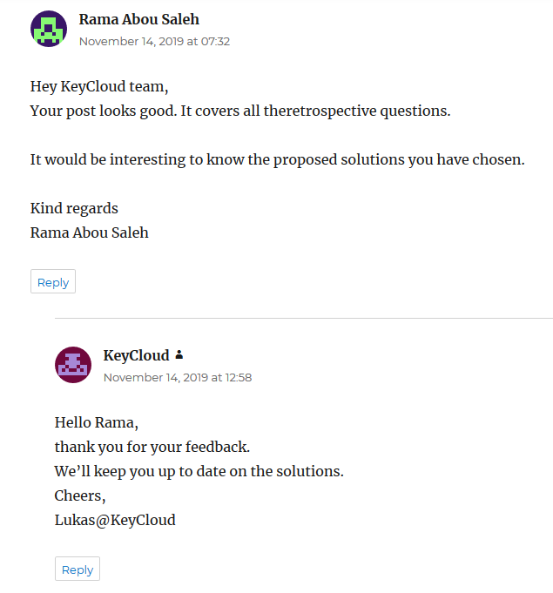

1. <https://mfj-testing.com/2019/11/14/retrospective/#comment-29>

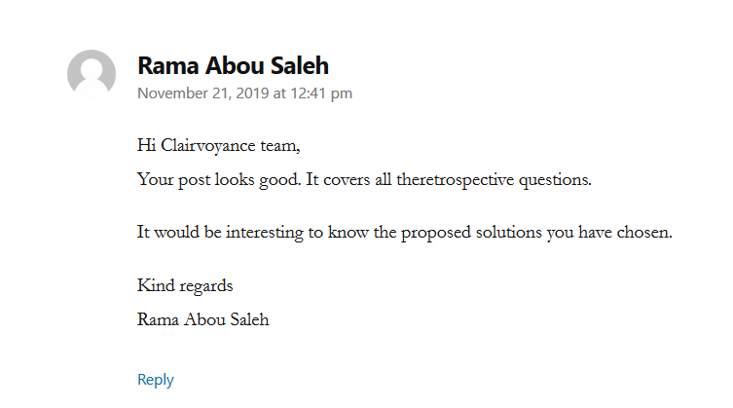

We were not able to find our Peer Review-Comments again (they were deleted). We added new ones again.

W8:

1. <https://partyplayer.wordpress.com/2019/11/22/week-8-class-and-database-diagrams/comment-page-1/#comment-34>

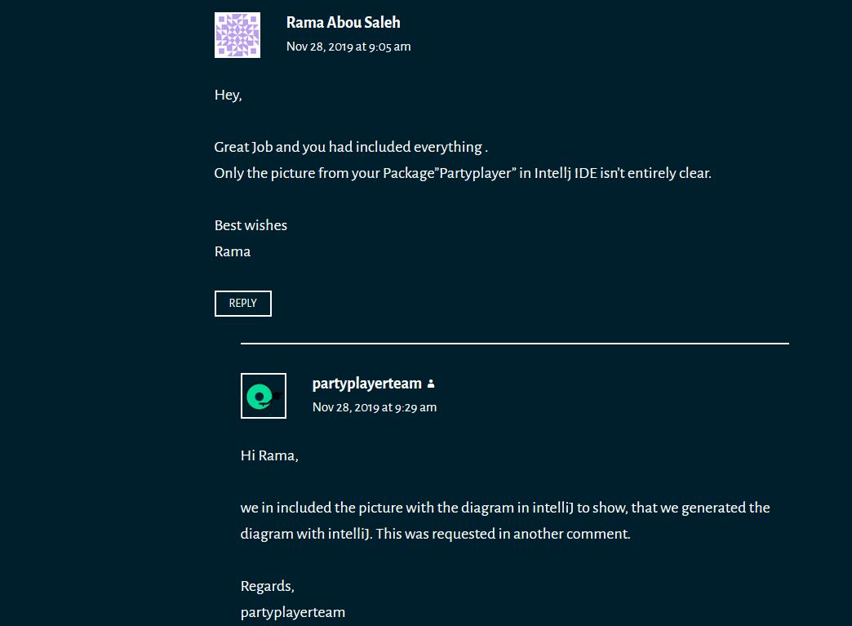

1. <https://mfj-testing.com/2019/11/24/class-diagrams/#comment-33>

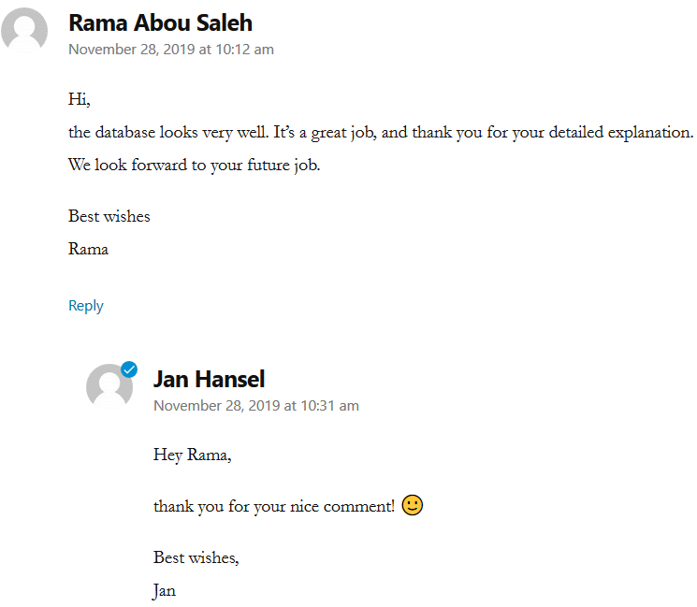

W9:

We were not able to find our Peer Review-Comments again (they were deleted). We added new ones again.

1. <https://gyrogame.de/2019/12/23/week-9-software-architecture-documentation/#comment-61>

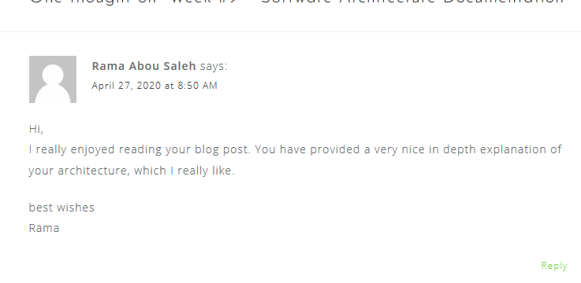

We were not able to find our Peer Review-Comments again (they were deleted). We added new ones again.

1. <https://blog.game-base.de/pow-9/#comment-30>

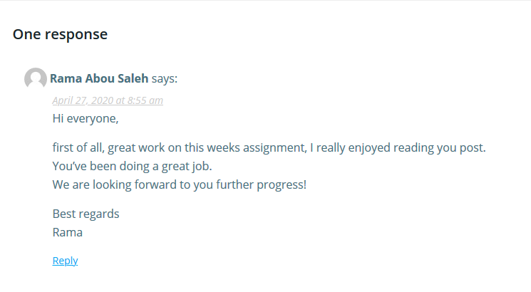

W11:

We were not able to find our Peer Review-Comments again (they were deleted). We added new ones again.

1. <https://evendo.gnaatz.de/?p=81#comment-40>



We were not able to find our Peer Review-Comments again (they were deleted). We added new ones again.

1. <https://partyplayer.wordpress.com/2019/12/03/midterm/comment-page-1/#comment-44>

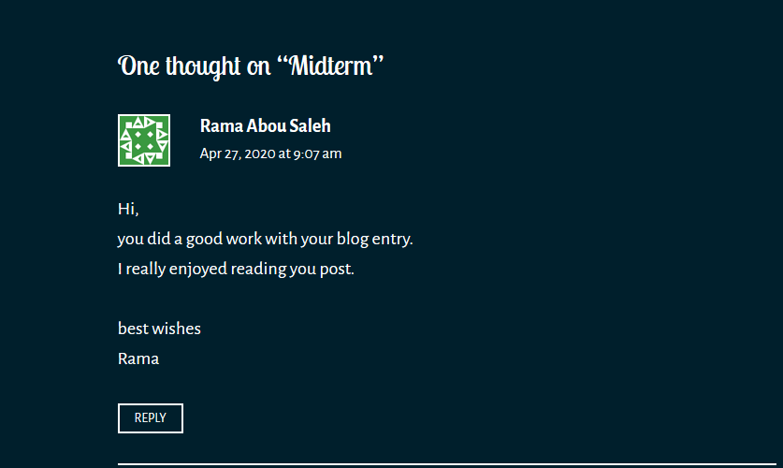

W2:

1. <https://logicgame775066249.wordpress.com/2020/04/24/risk-management/comment-page-1/#comment-44>

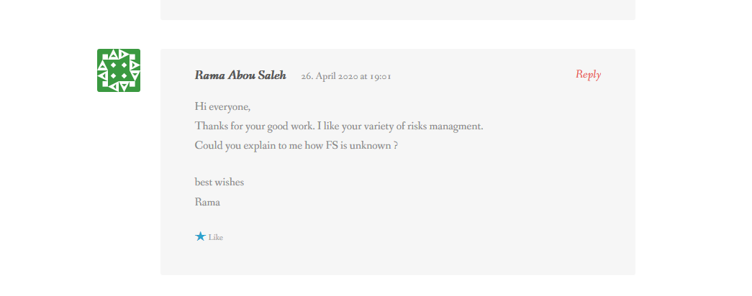

1. <http://blog.unitasks.net/2020/04/26/week-12-risk-management/#comment-50>

